**PROGRAM DEBUGGING**

Question-2

PROJECT – 3

1. **Dependency analysis screenshot**
2. **IMPACT OF CHAGING THE EXISTING REQUIREMENT #1 AND #2**

* In the previous requirement #1, user has to only enter the age which is approximate while the changes in the requirement #1 will ask the user for his date of birth, with this we can get the precise age of the user using the month,

Year and day.

* With the updated logic in requirement #2, we can get the precise amount of accumulated salary for the user based in the province.



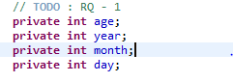

**Added month, year, and day to enable user to enter the date of birth.**



**Calculating age with user’s date of birth and current date.**

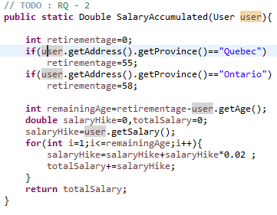

**Changes in salaryaccumulated( ) method to calculate accumulated salary according to the province.**

* **WEB #4**

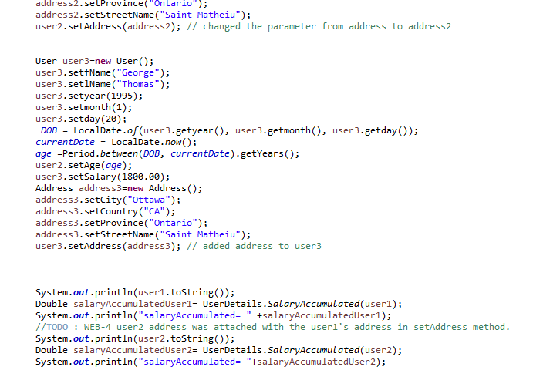

**Reason for the bug : user2 address was attached with the user1’s address in setAddress method.**

* **WEB #5**

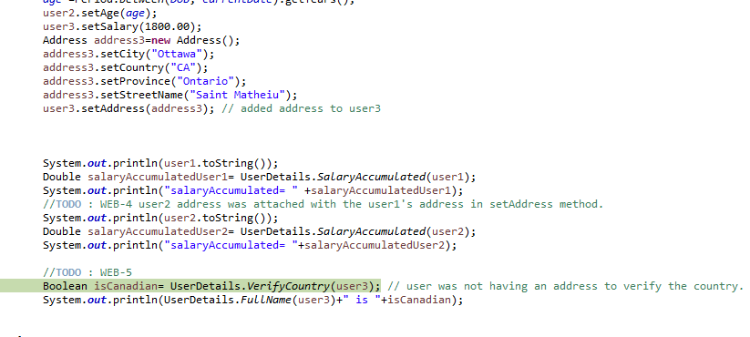

* **BUG : user was not having an address to verify the country.**
* **Error Log : user3 address was passed as null to verifycounty() method so method was throwing a null pointer exception.**

Output:

